Experiment No:-

Name: Bhagyashree Rajgonda Patil Roll No: 27
Class: MCA SY Semester: 3rd
Subject: Mobile Application Development Batch: M2
Q) Implementation and Demonstration of Implicit and Explicit Intents in Android Application.
- Implicit Intent
- AndroidManifest.xml

<?xml version="1.0" encoding="utf-8"?>
<manifest xmlns:android="http://schemas.android.com/apk/res/android"
xmlns:tools="http://schemas.android.com/tools">

<application
android:allowBackup="true"
android:dataExtractionRules="@xml/data_extraction_rules"
android:fullBackupContent="@xml/backup_rules"
android:icon="@mipmap/ic_launcher"
android:label="@string/app_name"
android:roundIcon="@mipmap/ic_launcher_round"
android:supportsRtl="true"
android:theme="@style/Theme.Implicit_Intent">
<activity
android:name=".MainActivity"
android:exported="true">
<intent-filter>
<action android:name="android.intent.action.MAIN" />

<category android:name="android.intent.category.LAUNCHER" />
</intent-filter>
</activity>
</application>
</manifest>
- Activity_main.xml

<?xml version="1.0" encoding="utf-8"?>
<RelativeLayout
xmlns:android="http://schemas.android.com/apk/res/android"
xmlns:tools="http://schemas.android.com/tools"
android:layout_width="match_parent"
android:layout_height="match_parent"
tools:context=".MainActivity">

<EditText
android:id="@+id/urlText"
android:layout_width="wrap_content"
android:layout_height="wrap_content"
android:layout_alignParentTop="true"
android:layout_centerHorizontal="true"
android:layout_marginTop="100dp"
android:ems="10" />

<Button
android:layout_width="wrap_content"
android:layout_height="wrap_content"
android:id="@+id/btnNavigate"
android:layout_below="@+id/urlText"
android:text="Navigate"
android:layout_centerHorizontal="true" />
</RelativeLayout>

- MainActivity.java

package com.example.hello_world;

import android.os.Bundle;
import androidx.activity.EdgeToEdge;
import androidx.appcompat.app.AppCompatActivity;
import androidx.core.graphics.Insets;
import androidx.core.view.ViewCompat;
import androidx.core.view.WindowInsetsCompat;
import com.example.implicit_intent.R;

public class MainActivity extends AppCompatActivity {

@Override
protected void onCreate(Bundle savedInstanceState) {
super.onCreate(savedInstanceState);
setContentView(R.layout.activity_main);

}
}

- Output

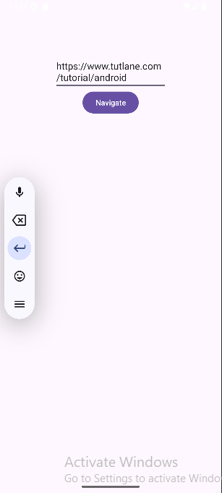 | 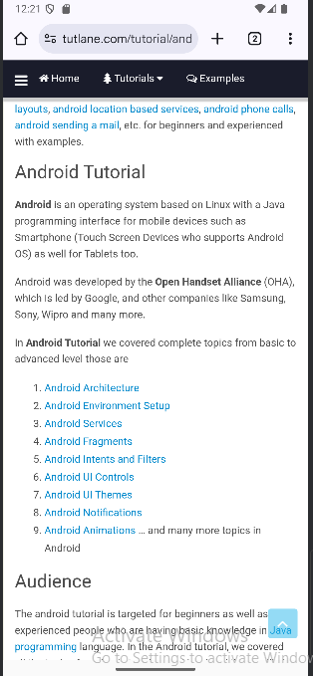

- Explicit Intent

- AndroidManifest.xml
<?xml version="1.0" encoding="utf-8"?>
<manifest xmlns:android="http://schemas.android.com/apk/res/android"
xmlns:tools="http://schemas.android.com/tools">

<application
android:allowBackup="true"
android:dataExtractionRules="@xml/data_extraction_rules"
android:fullBackupContent="@xml/backup_rules"
android:icon="@mipmap/ic_launcher"
android:label="@string/app_name"
android:roundIcon="@mipmap/ic_launcher_round"
android:supportsRtl="true"
android:theme="@style/Theme.Explicit_Intent">
<activity
android:name=".MainActivity"
android:exported="true">
<intent-filter>
<action android:name="android.intent.action.MAIN" />
<category android:name="android.intent.category.LAUNCHER" />
</intent-filter>
</activity>
<activity android:name=".ResultActivity" android:label="Explicit Intent - Activity2">
</activity>
</application>
</manifest>
- Activity_main.xml

<?xml version="1.0" encoding="utf-8"?>
<LinearLayout xmlns:android="http://schemas.android.com/apk/res/android"
android:orientation="vertical"
android:layout_width="match_parent"
android:layout_height="match_parent">
<TextView
android:layout_width="wrap_content"
android:layout_height="wrap_content"
android:layout_marginLeft="100dp"
android:layout_marginTop="150dp"
android:text="Enter First Number"
/>
<EditText
android:id="@+id/edtfirstNum"
android:layout_width="wrap_content"
android:layout_height="wrap_content"
android:layout_marginLeft="100dp"
android:ems="10">
</EditText>
<TextView
android:layout_width="wrap_content"
android:layout_height="wrap_content"
android:layout_marginLeft="100dp"
android:text="Enter Second Number"
/>

<EditText
android:id="@+id/edtsecondNum"
android:layout_width="wrap_content"
android:layout_height="wrap_content"
android:layout_marginLeft="100dp"
android:ems="10">
</EditText>
<Button
android:id="@+id/btnAdd"
android:layout_width="wrap_content"
android:layout_height="wrap_content"
android:layout_marginLeft="100dp"
android:text="Add"
/>
</LinearLayout>

- MainActivity.java

package com.example.explicit_intent;
import android.content.Intent;
import android.os.Bundle;
import android.view.View;
import android.widget.Button;
import android.widget.EditText;
import androidx.activity.EdgeToEdge;
import androidx.appcompat.app.AppCompatActivity;
import androidx.core.graphics.Insets;
import androidx.core.view.ViewCompat;
import androidx.core.view.WindowInsetsCompat;
public class MainActivity extends AppCompatActivity {
@Override
protected void onCreate(Bundle savedInstanceState) {
super.onCreate(savedInstanceState);
setContentView(R.layout.activity_main);

EditText editText1;
EditText editText2;
Button btnAdd;
editText1 = (EditText)findViewById(R.id.edtfirstNum);
editText2 = (EditText)findViewById(R.id.edtsecondNum);
btnAdd = (Button) findViewById(R.id.btnAdd);
btnAdd.setOnClickListener(new View.OnClickListener() {
@Override
public void onClick(View v) {
int num1 = Integer.parseInt(editText1.getText().toString());
int num2 = Integer.parseInt(editText2.getText().toString());
Intent intent = new Intent(MainActivity.this, ResultActivity.class);
intent.putExtra("SUM", num1 + " + " + num2 + " = " + (num1 + num2));
startActivity(intent);
}
});
}
}

- Result.xml

<?xml version="1.0" encoding="utf-8"?>
<LinearLayout xmlns:android="http://schemas.android.com/apk/res/android"
android:orientation="vertical"
android:layout_width="match_parent"
android:layout_height="match_parent">

<TextView
android:layout_width="wrap_content"
android:layout_height="wrap_content"
android:text="Addition"
android:textStyle="bold"
android:layout_marginLeft="100dp"
android:layout_marginTop="150dp"/>

<TextView
android:layout_width="wrap_content"
android:layout_height="wrap_content"
android:id="@+id/resultView"
android:layout_marginLeft="100dp"/>
</LinearLayout>

- ResultActivity.java

package com.example.explicit_intent;
import android.content.Intent;
import android.os.Bundle;
import android.widget.TextView;
import androidx.appcompat.app.AppCompatActivity;
public class ResultActivity extends AppCompatActivity {

@Override
protected void onCreate(Bundle savedInstanceState) {
super.onCreate(savedInstanceState);
setContentView(R.layout.result);
TextView textView = (TextView) findViewById(R.id.resultView);
Intent intent = getIntent();
String addition = (String) intent.getSerializableExtra("SUM");
textView.setText(addition);
}
}
- Output

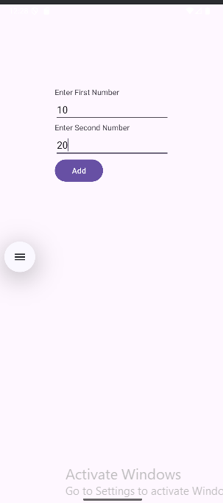 | 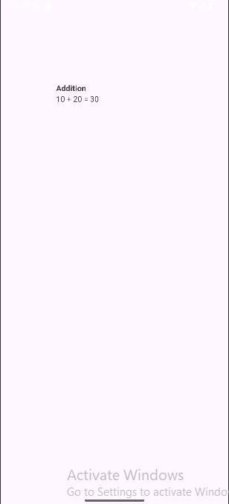

Cognitive (04) | Psychomotor Skill (04) | Affective Domain (02) | Total (10) | Sign

